**DAILY ONLINE ACTIVITIES SUMMARY**

|  |  |  |  |  |  |  |  |  |
| --- | --- | --- | --- | --- | --- | --- | --- | --- |
| **Date:** | **23/05/2020** | | | | | **Name:** | **AKASH S** | |
| **Sem & Sec** | **4TH&A** | | | | | **USN:** | **4AL18CS004** | |
| **Online Test Summary** | | | | | | | | |
| **Subject** | | **DATA COMMUNICATION** | | | | | | |
| **Max. Marks** | | **30** | | **Score** | | | **23** | |
| **Certification Course Summary** | | | | | | | | |
| **Course** | **GOOGLE ANALYTICS FOR BRGINNERS** | | | | | | | |
| **Certificate Provider** | | | **GOOGLE** | | **Duration** | | | **2.5 HOURS** |
| **Coding Challenges** | | | | | | | | |
| **Problem Statement:1: Write a c program to generate first N triangular Numbers(where N read from the keyboard).** | | | | | | | | |
| **Status: executed** | | | | | | | | |
| **Uploaded the report in Github** | | | | | **YES** | | | |
| **If yes Repository name** | | | | | [**https://github.com/akashacharya786/lockdown-c-coding**](https://github.com/akashacharya786/lockdown-c-coding) | | | |
| **Uploaded the report in slack** | | | | | **YES** | | | |

Online Test Summary:

18CS46 the test was from module-1 and module-2. There are 30 questions and the duration 40minutes.The score that I received was 23/30.

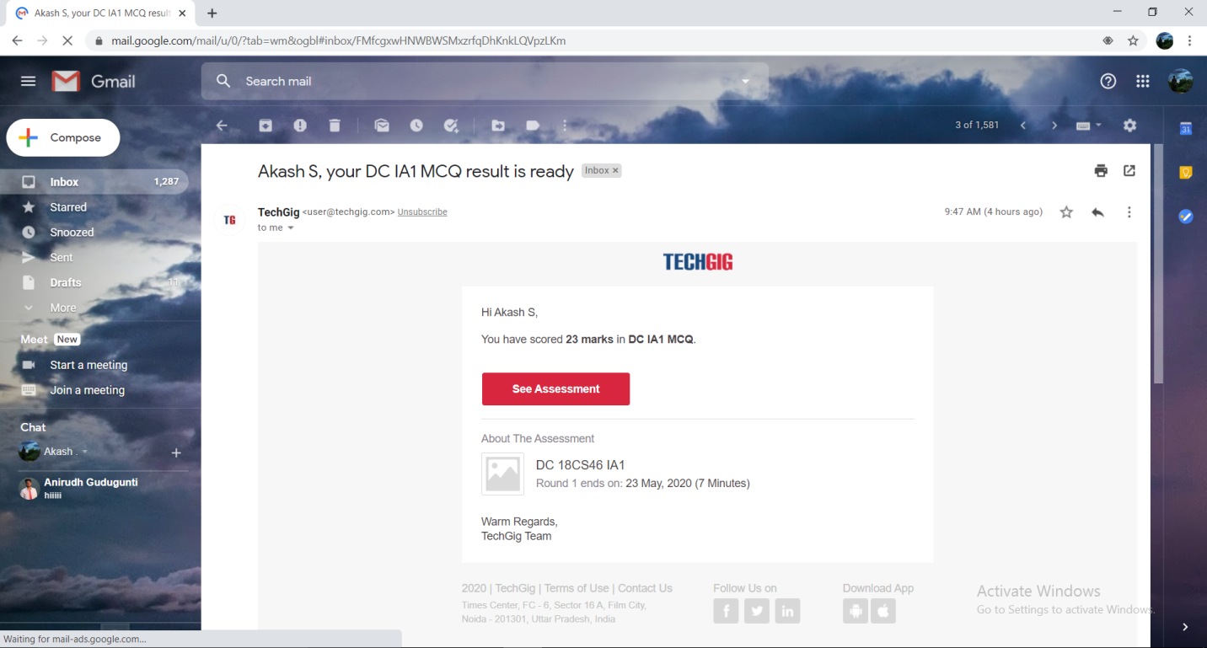

Online Certification course:

Name of the course: Google Analytics

Duration:2.5 hours

Today I have completed the course of google analytics for beginners.

Snap shot.

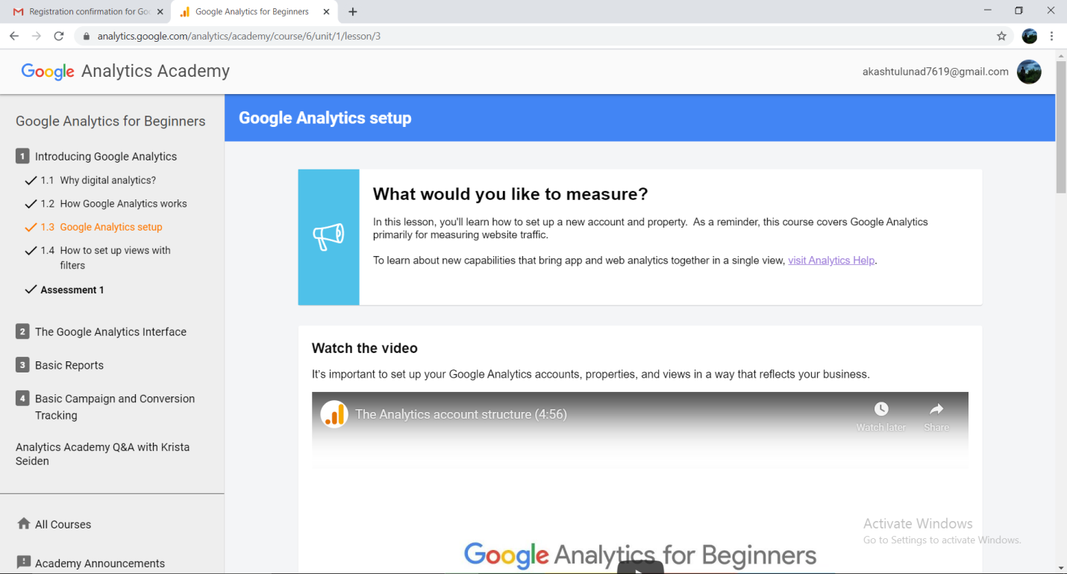

Online Coding summary:

Problem Statement:1. Write a C Program to generate first N Triangular Numbers (Where N is Read from the Key board).